

| Title: Implementation of Advanced JavaScript Concept |
| --- |

**AIM:** To Implement the Concept of Advanced JavaScript

**Problem Definition:**

-Demonstrate the Concept of Advanced JavaScript With the help of Example.

*(Students have to perform the task assigned within group and demonstrate the same).

**Resources used:**

1. Google
2. Geeksforgeeks
3. Tutorialspoint
4. VSCode

**_____________________________________________________________________**

**Expected OUTCOME of Experiment:**

**CO 1:**.Build full stack applications in JavaScript using the MERN technologies.

**___________________________________________________________________**

**Books/ Journals/ Websites referred:**

1. Shelly Powers Learning Node O’ Reilly 2 nd Edition, 2016.

**Pre Lab/ Prior Concepts:**

**Methodology:**

### 1. Callback Hell, Promise Chaining, and Async/Await

#### Callback Hell

1. Define Functions: Create functions with callbacks for asynchronous tasks.
2. Nest Callbacks: Chain multiple asynchronous operations using callbacks.
3. Handle Errors: Include error handling for each callback.

#### Promise Chaining

1. Define Functions Returning Promises: Create functions that return promises.
2. Chain Promises: Use .then() to chain multiple asynchronous operations.
3. Handle Errors: Add .catch() to handle errors in the chain.

#### Async/Await

1. Define Async Function: Create an async function to handle asynchronous operations.
2. Use Await: Inside the async function, use await to pause execution until promises resolve.
3. Handle Errors: Use try...catch blocks to handle errors.

### 2. Filter Unique Array Members

1. Define Function: Create a function unique(arr) that takes an array as input.
2. Use a Set: Convert the array to a Set to remove duplicates.
3. Return Array: Convert the Set back to an array and return it.

### 3. Filter Anagrams

1. Define Function: Create a function to filter anagrams from an array of words.
2. Sort Characters: For each word, sort its characters and use this as a key.
3. Group Words: Group words with the same key (sorted characters) as anagrams.
4. Return Groups: Return the grouped anagrams.

### 4. Iterable Keys

1. Create a Map: Define a Map object with key-value pairs.
2. Get Keys: Retrieve the keys from the map using map.keys().
3. Convert to Array: Convert the iterable keys to an array using Array.from().
4. Apply Array Methods: Use array methods like .push() on the array of keys.

### 5. Fetch Users from GitHub

1. Define Async Function: Create an async function getUsers(names) that takes an array of GitHub usernames.
2. Fetch Data: Use fetch() to request user data from the GitHub API for each username.
3. Handle Responses: Convert the responses to JSON.
4. Return Users: Collect and return the array of user data

**Implementation Details:**

Task

1) WAP for Callback hell, Promise Chaining and Async await for any application  
Code:

<!DOCTYPE *html*>

<html *lang*="en">

<head>

<meta *charset*="UTF-8">

<meta *name*="viewport" *content*="width=device-width, initial-scale=1.0">

<title>Callback hell,Promise,Async</title>

</head>

<body>

<h1>Callback hell,Promise,Async</h1>

<button *id*="run-callback-hell">Callback Hell</button>

<button *id*="run-promise-chaining">Promise </button>

<button *id*="run-async-await">Async/Await</button>

<script>

function getData(*callback*) {

setTimeout(() => {

console.log("Data fetched c");

callback(null, "Data c");

}, 1000);

}

function processData(*data*, *callback*) {

setTimeout(() => {

console.log("Data processed c");

callback(null, "Processed Data c");

}, 1000);

}

function saveData(*data*, *callback*) {

setTimeout(() => {

console.log("Data saved c");

callback(null, "Saved Data c ");

}, 1000);

}

document.getElementById('run-callback-hell').addEventListener('click', () => {

getData((*err*, *data*) => {

if (*err*) throw *err*;

processData(*data*, (*err*, *processedData*) => {

if (*err*) throw *err*;

saveData(*processedData*, (*err*, *savedData*) => {

if (*err*) throw *err*;

console.log(*savedData*);

});

});

});

});

function getDataPromise() {

return new Promise((*resolve*) => {

setTimeout(() => {

console.log("Data fetched p");

resolve("Data p");

}, 1000);

});

}

function processDataPromise(*data*) {

return new Promise((*resolve*) => {

setTimeout(() => {

console.log("Data processed p");

resolve("Processed Data p");

}, 1000);

});

}

function saveDataPromise(*data*) {

return new Promise((*resolve*) => {

setTimeout(() => {

console.log("Data saved p");

resolve("Saved Data p");

}, 1000);

});

}

document.getElementById('run-promise-chaining').addEventListener('click', () => {

getDataPromise()

.then(processDataPromise)

.then(saveDataPromise)

.then((*savedData*) => console.log(*savedData*));

});

async function handleData() {

try {

const data = await getDataPromise();

const processedData = await processDataPromise(data);

const savedData = await saveDataPromise(processedData);

console.log(savedData);

} catch (error) {

console.error(error);

}

}

document.getElementById('run-async-await').addEventListener('click', handleData);

</script>

</body>

</html>

Output Screenshots :   
  
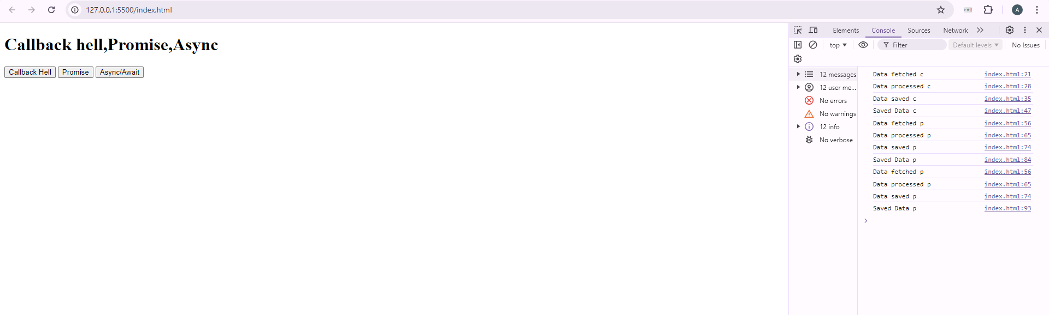  
  
  
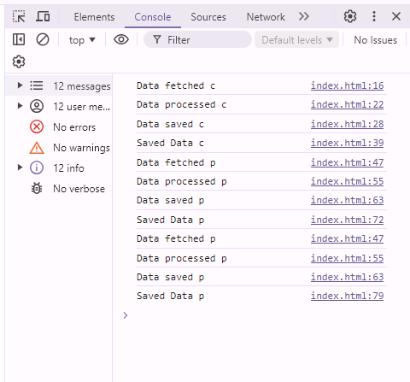

2) Filter unique array members

Let arr be an array.

Create a function unique(arr) that should return an array with unique items of arr

Code:

<!DOCTYPE html>

<html lang="en">

<head>

<meta charset="UTF-8">

<meta name="viewport" content="width=device-width, initial-scale=1.0">

<title>Unique Array Filter</title>

<style>

body {

font-family: Arial, sans-serif;

margin: 20px;

}

input,

button {

margin-bottom: 10px;

padding: 5px;

}

#result {

margin-top: 10px;

font-weight: bold;

}

</style>

</head>

<body>

<h1>Unique Array Filter</h1>

<label for="arrayInput">Enter array elements (comma-separated):</label>

<input type="text" id="arrayInput" placeholder="Enter values">

<button onclick="filterUnique()">Get Unique Values</button>

<div id="result"></div>

<script>

function unique(arr) {

return Array.from(new Set(arr));

}

function filterUnique() {

const input = document.getElementById('arrayInput').value;

const array = input.split(',').map(item => item.trim()).filter(item => item !== '');

const uniqueValues = unique(array);

document.getElementById('result').textContent = `Unique Values: ${uniqueValues.join(', ')}`;

}

</script>

</body>

</html>

Output Screenshot:

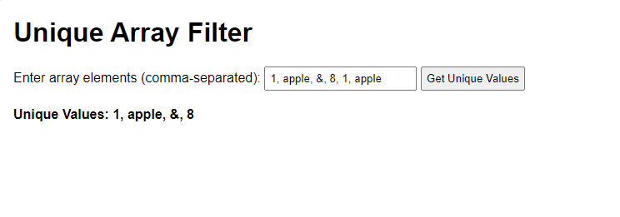

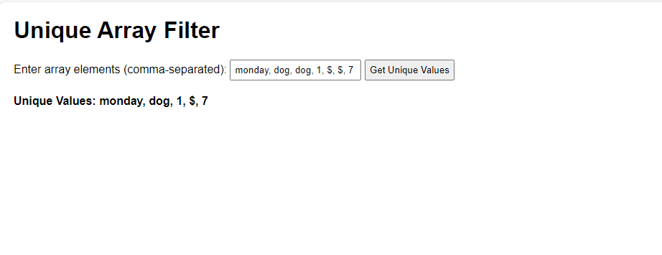

3) Filter anagrams

Anagrams are words that have the same number of same letters, but in different order.

Code :

<!DOCTYPE *html*>

<html *lang*="en">

<head>

<meta *charset*="UTF-8">

<meta *name*="viewport" *content*="width=device-width, initial-scale=1.0">

<title>Anagram Filter</title>

<style>

body {

font-family: Arial, sans-serif;

margin: 20px;

}

#output {

margin-top: 20px;

}

</style>

</head>

<body>

<h1>Anagram Filter</h1>

<input *type*="text" *id*="inputWords" *placeholder*="Enter words separated by commas" *size*="50">

<button *onclick*="filterAndDisplayAnagrams()">Filter Anagrams</button>

<div *id*="output"></div>

<script>

*// Function to sort the characters in a word*

function sortWord(*word*) {

return *word*.split('').sort().join('');

}

function filterAnagrams(*words*) {

const anagrams = {};

*words*.forEach(*word* => {

const sortedWord = sortWord(*word*);

if (anagrams[sortedWord]) {

anagrams[sortedWord].push(*word*);

} else {

anagrams[sortedWord] = [*word*];

}

});

const result = [];

for (const key in anagrams) {

if (anagrams[key].length > 1) {

result.push(anagrams[key]);

}

}

return result;

}

function filterAndDisplayAnagrams() {

const input = document.getElementById('inputWords').value;

const words = input.split(',').map(*word* => *word*.trim());

const anagramGroups = filterAnagrams(words);

const outputDiv = document.getElementById('output');

outputDiv.innerHTML = '<h2>Anagram Groups:</h2>';

if (anagramGroups.length > 0) {

anagramGroups.forEach(*group* => {

outputDiv.innerHTML += `<p>${*group*.join(', ')}</p>`;

});

} else {

outputDiv.innerHTML += '<p>No anagrams found.</p>';

}

}

</script>

</body>

</html>

Output Screenshots :

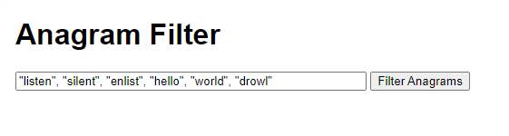

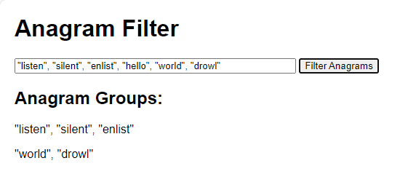

4) Iterable keys

We’d like to get an array of map.keys() in a variable and then apply array-specific methods to it, e.g. .push.

Code:

<!DOCTYPE *html*>

<html *lang*="en">

<head>

<meta *charset*="UTF-8">

<meta *name*="viewport" *content*="width=device-width, initial-scale=1.0">

<title>Iterable Keys</title>

</head>

<body>

<h1>Iterable Keys</h1>

<form *id*="map-form">

<div *class*="input-group">

<label *for*="key-input">Key:</label>

<input *type*="text" *id*="key-input" *required*>

</div>

<br>

<div *class*="input-group">

<label *for*="value-input">Value:</label>

<input *type*="number" *id*="value-input" *required*>

</div>

<br>

<button *type*="submit">Add to Map</button>

</form>

<h1>Map Entries</h1>

<table *id*="map-table">

<thead>

<tr>

<th>Key</th>

<th>Value</th>

</tr>

</thead>

<tbody *id*="map-rows">

</tbody>

</table>

<script>

const map = new Map();

document.getElementById('map-form').addEventListener('submit', (*event*) => {

*event*.preventDefault();

const key = document.getElementById('key-input').value;

const value = parseInt(document.getElementById('value-input').value, 10);

if (key && !isNaN(value)) {

map.set(key, value);

document.getElementById('key-input').value = '';

document.getElementById('value-input').value = '';

updateTable();

} else {

alert('Please enter valid key and value.');

}

});

function updateTable() {

const rowsContainer = document.getElementById('map-rows');

rowsContainer.innerHTML = '';

map.forEach((*value*, *key*) => {

const row = document.createElement('tr');

const keyCell = document.createElement('td');

keyCell.textContent = *key*;

const valueCell = document.createElement('td');

valueCell.textContent = *value*;

row.appendChild(keyCell);

row.appendChild(valueCell);

rowsContainer.appendChild(row);

});

}

document.getElementById('show-keys').addEventListener('click', () => {

updateTable();

});

</script>

</body>

</html>

Output Screenshot:

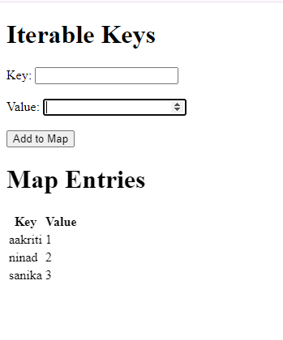

5) Fetch users from GitHub

Create an async function getUsers(names), that gets an array of GitHub logins, fetches the users from GitHub and returns an array of GitHub users.

Code:

<!DOCTYPE *html*>

<html *lang*="en">

<head>

<meta *charset*="UTF-8">

<meta *name*="viewport" *content*="width=device-width, initial-scale=1.0">

<title>Fetch Users from GitHub</title>

</head>

<body>

<h1>Fetch Users from GitHub</h1>

<input *type*="text" *id*="githubLogins" *placeholder*="Enter GitHub logins separated by commas" *size*="50">

<button *onclick*="fetchGitHubUsers()">Fetch Users</button>

<div *id*="githubOutput"></div>

<script>

async function getUsers(*names*) {

const requests = *names*.map(*name* => fetch(`https://api.github.com/users/${*name*}`));

const responses = await Promise.all(requests);

const users = await Promise.all(responses.map(*response* => *response*.json()));

return users;

}

async function fetchGitHubUsers() {

const input = document.getElementById('githubLogins').value;

const names = input.split(',').map(*name* => *name*.trim());

const users = await getUsers(names);

const outputDiv = document.getElementById('githubOutput');

outputDiv.innerHTML = '<h2>GitHub Users:</h2>';

users.forEach(*user* => {

if (*user*.message !== 'Not Found') {

outputDiv.innerHTML += `

<div>

<img src="${*user*.avatar_url}" alt="${*user*.login}" width="50" height="50">

<p><strong>${*user*.login}</strong></p>

<p>${*user*.name || ''}</p>

<p>${*user*.bio || ''}</p>

</div>

<hr>

`;

} else {

outputDiv.innerHTML += `<p>User ${*user*.login} not found.</p><hr>`;

}

});

}

</script>

</body>

</html>

Output Screenshots :

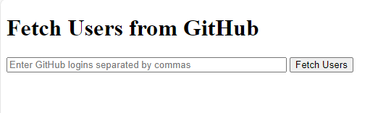

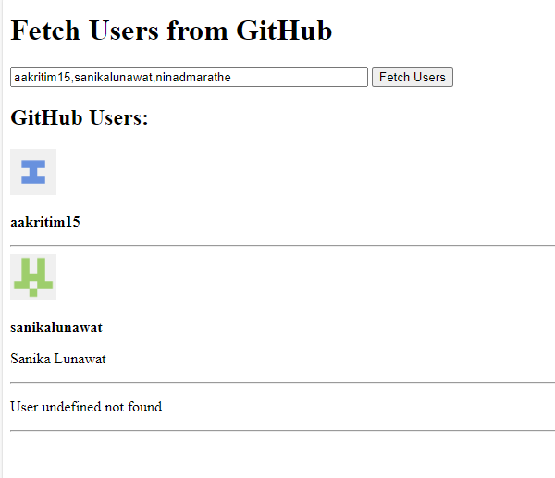

**Steps for execution:**

1. Create HTML file
2. Write java script logic for the given question
3. Test and debug if required
4. Check console.

**Conclusion:**

Learned advanced javascript functions.